Ambient Systems
Design Brief
User Stories

Finance Teams
- Finance teams can forecast revenues and expenses
- Finance teams can prepare reports for securing long-term funding and investments
- Finance teams can calculate and minimize tax
- Finance teams can reduce costs
- Finance teams can manage cash flows and revenues transparently
- Finance teams can identify and manage risks
- Finance teams can ensure compliance with regulations
- Finance teams can analyze financial data to generate insights for decision-making.

Operations
- Operations teams can translate metrics/goals/KPIs into operational tasks
- Operations teams can map operational tasks into financial goals
- Operations teams can identify operational drivers
- Operations teams can prioritize and sequence key value added tasks
- Operations teams can define task objectives and success criteria
- Operations teams can use data to communicate and align

Data:
- Finance teams can access data from different systems
- Finance teams can get data from operations using IoT

Team:
- Ops and finance teams can align goals and objectives between finance and operations
- Ops and finance teams can see the relevant data for each of our work tasks
- Ops and finance teams can collaborate on analysis and decision making
- Ops and finance teams can do a continuous improvement of the process.
- Ops and finance teams can partake in shared accountability and performance management.
- Ops and finance teams can utilize communication tools for seamless collaboration.

User Personas -- Finance

FP&A Team Persona:
- Role: Usually under treasury, responsible for planning and forecasting.
- Responsibilities: Focuses on financial planning and analysis, including forecasting revenues and expenses, budgeting, and providing insights to support strategic decision-making.
- Needs: Requires tools and features that enable accurate forecasting, scenario planning, budget management, and the ability to analyze financial data to support business objectives.

Accounting Team Persona:
- Role: Usually under controls team, responsible for costs and compliance.
- Responsibilities: Primarily concerned with managing costs, ensuring compliance with regulatory requirements and internal policies, and maintaining accurate financial records.
- Needs: Requires tools and features that streamline cost management processes, facilitate compliance with regulatory standards, automate financial reporting tasks, and provide visibility into financial data for auditing and reporting purposes.

User Persona – ‘Ops’:

Transportation Operations Team Persona:
- Role: Oversees the operational aspects of transportation services, including fleet management, route optimization, and logistics coordination.
- Responsibilities:
  - Ensures efficient utilization of vehicles and drivers to meet delivery schedules and customer demands.
  - Manages routing and scheduling to minimize transit times, fuel consumption, and operational costs.
  - Monitors vehicle performance and maintenance schedules to ensure fleet reliability and compliance with safety regulations.
  - Coordinates with suppliers, carriers, and distribution partners to optimize freight movement and logistics operations.
- Needs:
  - Requires tools and solutions that offer real-time tracking and monitoring of vehicle fleets, including GPS tracking, telematics data, and route optimization capabilities.
  - Seeks insights and analytics to identify opportunities for route optimization, fuel savings, and operational efficiency improvements.
  - Values solutions that provide predictive analytics for demand forecasting, maintenance planning, and risk mitigation in transportation operations.
  - Prefers mobile-friendly interfaces and communication channels to facilitate real-time updates, alerts, and coordination with drivers and logistics partners.
- Goals:
  - Improve on-time delivery performance and customer satisfaction.
  - Optimize fleet utilization and fuel efficiency to reduce operating costs.
  - Enhance safety and compliance with regulatory requirements in transportation operations.
  - Increase visibility and transparency across the supply chain to improve decision-making and responsiveness.
- Challenges:
  - Managing fluctuations in demand and capacity constraints in transportation networks.
  - Addressing driver shortages, retention, and training issues.
  - Navigating regulatory complexities and compliance requirements in the transportation industry.
  - Adapting to evolving market dynamics, technological advancements, and customer expectations in the transportation sector.

Construction Operations Team Persona:
- Role: Oversees the operational activities involved in construction projects, including project planning, resource allocation, scheduling, and site management.
- Responsibilities:
  - Manages project timelines, budgets, and resources to ensure successful completion of construction projects.
  - Coordinates with subcontractors, suppliers, and vendors to procure materials, equipment, and services needed for construction activities.
  - Monitors progress and performance against project milestones and benchmarks to identify potential delays, cost overruns, and quality issues.
  - Implements safety protocols and regulatory compliance measures to maintain a safe work environment and mitigate risks on construction sites.
- Needs:
  - Requires tools and solutions that facilitate project planning, scheduling, and resource allocation for construction activities.
  - Seeks insights and analytics to track project progress, monitor costs, and identify potential risks or bottlenecks in construction projects.
  - Values solutions that offer collaboration and communication features to streamline coordination among project stakeholders and subcontractors.
  - Prefers mobile applications and cloud-based platforms that enable real-time access to project data, documentation, and communication channels from any location.
- Goals:
  - Deliver construction projects on time, within budget, and according to quality standards.
  - Optimize resource utilization and productivity to maximize project efficiency and profitability.
  - Enhance safety performance and compliance with regulatory requirements in construction operations.
  - Improve communication and collaboration among project teams and stakeholders to minimize delays and disruptions.
- Challenges:
  - Managing project complexities, uncertainties, and unforeseen challenges in construction projects.
  - Balancing competing priorities and constraints, such as time, cost, and quality, in construction operations.
  - Addressing workforce shortages, skill gaps, and labor productivity issues in the construction industry.
  - Adapting to changing market conditions, technological advancements, and sustainability considerations in construction practices.

Commercial Real Estate Operations Team Persona:
- Role: Manages the operational aspects of commercial real estate properties, including leasing, property management, tenant services, and facility maintenance.
- Responsibilities:
  - Oversees leasing activities, tenant relations, and lease administration to maximize occupancy rates and rental revenues.
  - Manages property maintenance, repairs, and capital improvements to ensure tenant satisfaction and preserve property value.
  - Implements operational efficiencies and cost-saving initiatives to optimize property performance and profitability.
  - Coordinates with service providers, vendors, and contractors to deliver high-quality facilities management services and amenities to tenants.
- Needs:
  - Requires tools and solutions that facilitate lease management, tenant communications, and property maintenance in commercial real estate operations.
  - Seeks insights and analytics to track property performance, monitor tenant satisfaction, and identify opportunities for revenue optimization and cost containment.
  - Values solutions that offer integration with accounting systems, reporting tools, and other business applications to streamline property management processes and financial operations.
  - Prefers user-friendly interfaces and dashboards that provide visibility into key performance indicators, property metrics, and operational trends for informed decision-making.
- Goals:
  - Maximize occupancy rates and rental income for commercial real estate properties.
  - Optimize property operating expenses and maintenance costs while delivering high-quality tenant services.
  - Enhance tenant satisfaction and retention through proactive communication, responsiveness, and value-added amenities.
  - Improve operational efficiency and transparency in commercial real estate management processes.
- Challenges:
  - Managing tenant turnover, lease negotiations, and lease administration in a competitive market.
  - Addressing maintenance and repair issues, property upgrades, and capital improvement projects to maintain property value and attractiveness.
  - Navigating regulatory requirements, compliance standards, and sustainability initiatives in commercial real estate operations.
  - Adapting to changing tenant preferences, market dynamics, and technological innovations in the commercial real estate industry.

Tailoring the Operations Team Persona to specific industries allows for a deeper understanding of the unique challenges, priorities, and requirements faced by operations professionals in each sector. This enables your app to provide targeted solutions and value-added features that address the specific needs of users in transportation, construction, and commercial real estate operations.

User Personas -- Finance

FP&A Team Persona:
- Role: Usually under treasury, responsible for planning and forecasting.
- Responsibilities: Focuses on financial planning and analysis, including forecasting revenues and expenses, budgeting, and providing insights to support strategic decision-making.
- Needs: Requires tools and features that enable accurate forecasting, scenario planning, budget management, and the ability to analyze financial data to support business objectives.

Accounting Team Persona:
- Role: Usually under controls team, responsible for costs and compliance.
- Responsibilities: Primarily concerned with managing costs, ensuring compliance with regulatory requirements and internal policies, and maintaining accurate financial records.
- Needs: Requires tools and features that streamline cost management processes, facilitate compliance with regulatory standards, automate financial reporting tasks, and provide visibility into financial data for auditing and reporting purposes.

User Persona – ‘Ops’:

Transportation Operations Team Persona:
- Role: Oversees the operational aspects of transportation services, including fleet management, route optimization, and logistics coordination.
- Responsibilities:
  - Ensures efficient utilization of vehicles and drivers to meet delivery schedules and customer demands.
  - Manages routing and scheduling to minimize transit times, fuel consumption, and operational costs.
  - Monitors vehicle performance and maintenance schedules to ensure fleet reliability and compliance with safety regulations.
  - Coordinates with suppliers, carriers, and distribution partners to optimize freight movement and logistics operations.
- Needs:
  - Requires tools and solutions that offer real-time tracking and monitoring of vehicle fleets, including GPS tracking, telematics data, and route optimization capabilities.
  - Seeks insights and analytics to identify opportunities for route optimization, fuel savings, and operational efficiency improvements.
  - Values solutions that provide predictive analytics for demand forecasting, maintenance planning, and risk mitigation in transportation operations.
  - Prefers mobile-friendly interfaces and communication channels to facilitate real-time updates, alerts, and coordination with drivers and logistics partners.
- Goals:
  - Improve on-time delivery performance and customer satisfaction.
  - Optimize fleet utilization and fuel efficiency to reduce operating costs.
  - Enhance safety and compliance with regulatory requirements in transportation operations.
  - Increase visibility and transparency across the supply chain to improve decision-making and responsiveness.
- Challenges:
  - Managing fluctuations in demand and capacity constraints in transportation networks.
  - Addressing driver shortages, retention, and training issues.
  - Navigating regulatory complexities and compliance requirements in the transportation industry.
  - Adapting to evolving market dynamics, technological advancements, and customer expectations in the transportation sector.

Construction Operations Team Persona:
- Role: Oversees the operational activities involved in construction projects, including project planning, resource allocation, scheduling, and site management.
- Responsibilities:
  - Manages project timelines, budgets, and resources to ensure successful completion of construction projects.
  - Coordinates with subcontractors, suppliers, and vendors to procure materials, equipment, and services needed for construction activities.
  - Monitors progress and performance against project milestones and benchmarks to identify potential delays, cost overruns, and quality issues.
  - Implements safety protocols and regulatory compliance measures to maintain a safe work environment and mitigate risks on construction sites.
- Needs:
  - Requires tools and solutions that facilitate project planning, scheduling, and resource allocation for construction activities.
  - Seeks insights and analytics to track project progress, monitor costs, and identify potential risks or bottlenecks in construction projects.
  - Values solutions that offer collaboration and communication features to streamline coordination among project stakeholders and subcontractors.
  - Prefers mobile applications and cloud-based platforms that enable real-time access to project data, documentation, and communication channels from any location.
- Goals:
  - Deliver construction projects on time, within budget, and according to quality standards.
  - Optimize resource utilization and productivity to maximize project efficiency and profitability.
  - Enhance safety performance and compliance with regulatory requirements in construction operations.
  - Improve communication and collaboration among project teams and stakeholders to minimize delays and disruptions.
- Challenges:
  - Managing project complexities, uncertainties, and unforeseen challenges in construction projects.
  - Balancing competing priorities and constraints, such as time, cost, and quality, in construction operations.
  - Addressing workforce shortages, skill gaps, and labor productivity issues in the construction industry.
  - Adapting to changing market conditions, technological advancements, and sustainability considerations in construction practices.

Commercial Real Estate Operations Team Persona:
- Role: Manages the operational aspects of commercial real estate properties, including leasing, property management, tenant services, and facility maintenance.
- Responsibilities:
  - Oversees leasing activities, tenant relations, and lease administration to maximize occupancy rates and rental revenues.
  - Manages property maintenance, repairs, and capital improvements to ensure tenant satisfaction and preserve property value.
  - Implements operational efficiencies and cost-saving initiatives to optimize property performance and profitability.
  - Coordinates with service providers, vendors, and contractors to deliver high-quality facilities management services and amenities to tenants.
- Needs:
  - Requires tools and solutions that facilitate lease management, tenant communications, and property maintenance in commercial real estate operations.
  - Seeks insights and analytics to track property performance, monitor tenant satisfaction, and identify opportunities for revenue optimization and cost containment.
  - Values solutions that offer integration with accounting systems, reporting tools, and other business applications to streamline property management processes and financial operations.
  - Prefers user-friendly interfaces and dashboards that provide visibility into key performance indicators, property metrics, and operational trends for informed decision-making.
- Goals:
  - Maximize occupancy rates and rental income for commercial real estate properties.
  - Optimize property operating expenses and maintenance costs while delivering high-quality tenant services.
  - Enhance tenant satisfaction and retention through proactive communication, responsiveness, and value-added amenities.
  - Improve operational efficiency and transparency in commercial real estate management processes.
- Challenges:
  - Managing tenant turnover, lease negotiations, and lease administration in a competitive market.
  - Addressing maintenance and repair issues, property upgrades, and capital improvement projects to maintain property value and attractiveness.
  - Navigating regulatory requirements, compliance standards, and sustainability initiatives in commercial real estate operations.
  - Adapting to changing tenant preferences, market dynamics, and technological innovations in the commercial real estate industry.

Tailoring the Operations Team Persona to specific industries allows for a deeper understanding of the unique challenges, priorities, and requirements faced by operations professionals in each sector. This enables your app to provide targeted solutions and value-added features that address the specific needs of users in transportation, construction, and commercial real estate operations.

Customer:

Ambient Systems would be an attractive solution for transportation companies seeking to enhance their financial management capabilities while also optimizing operational performance. The target audience for this product includes:

- Transportation Companies:
  - Trucking companies, freight carriers, logistics providers, and other transportation businesses looking to streamline their financial processes, optimize cash flow, and mitigate financial risks.
- Finance Professionals:
  - CFOs, finance directors, controllers, and financial analysts responsible for managing the financial health of transportation companies and making strategic financial decisions.
- Operations Managers:
  - Operations managers, supply chain managers, and logistics coordinators interested in leveraging financial insights to optimize operational efficiency, reduce costs, and improve performance.
- Investors and Stakeholders:
  - Investors, shareholders, and stakeholders in transportation companies seeking greater transparency, financial stability, and strategic planning capabilities.
- Compliance Officers:
  - Compliance officers and regulatory compliance professionals responsible for ensuring adherence to financial regulations and industry standards within transportation companies.
- Enterprise Software Buyers:
  - IT decision-makers and enterprise software buyers responsible for evaluating and implementing comprehensive financial management solutions for transportation businesses.

Overall, Ambient Systems appeals to a diverse audience spanning finance, operations, compliance, and IT departments within transportation companies, offering a unified platform to drive financial performance, operational efficiency, and regulatory compliance across the organization.

Data

Data Type | Transportation Industry | Construction Industry | Commercial Real Estate Industry
Financial Data | Revenue from transportation services, fuel costs, maintenance expenses, vehicle acquisition costs, insurance premiums | Project budgets, costs of materials, labor expenses, equipment rentals, subcontractor fees, project revenues | Rental income, lease agreements, property operating expenses, property taxes, maintenance costs, capital expenditures
Operational Data | Fleet utilization rates, on-time performance, fuel efficiency, vehicle maintenance schedules, driver productivity | Project timelines, progress milestones, resource allocation, equipment utilization, safety incidents | Occupancy rates, lease renewal rates, tenant turnover, building maintenance schedules, energy consumption
Task and Project Data | Transportation routes, delivery schedules, vehicle assignments, load capacities, dispatching activities | Project plans, blueprints, work orders, change orders, material orders, subcontractor agreements | Property listings, lease negotiations, tenant improvements, property inspections, asset management activities
Performance Metrics | Freight turnover rates, delivery lead times, driver safety scores, customer satisfaction ratings, cost per mile | Project completion rates, schedule adherence, budget variance, rework rates, customer satisfaction scores | Net operating income (NOI), return on investment (ROI), cash flow yield, tenant satisfaction ratings, lease-up rates
External Data | Fuel prices, regulatory changes, weather conditions, geopolitical events | Permit approvals, zoning regulations, material prices, labor availability, economic trends | Market demand, rental trends, interest rates, regulatory changes, economic indicators

Competitors

- Business Intelligence (BI) Tools: BI tools such as Tableau, Power BI, and QlikView enable users to connect to various data sources, including databases, spreadsheets, and cloud services. Users can then create interactive dashboards and reports to visualize and analyze data from different sources in one centralized location.
- Enterprise Resource Planning (ERP) Systems: ERP systems like SAP, Oracle, and Microsoft Dynamics offer integrated suites of applications for managing various aspects of business operations, including finance, supply chain, and project management. These systems consolidate data from different departments and provide real-time insights into key performance metrics.
- Construction Management Software: Construction management software such as Procore, Autodesk BIM 360, and PlanGrid helps construction companies streamline project management tasks and centralize project data. These platforms allow users to track project progress, manage documents, and collaborate with stakeholders in a unified environment.
- Real Estate Portfolio Management Software: Real estate portfolio management software like Yardi, MRI Software, and RealPage provides tools for managing commercial real estate assets, leases, and financial performance. These platforms enable users to consolidate property data, track lease agreements, and analyze portfolio performance.
- Integrated Data Platforms: Integrated data platforms such as Snowflake, [Third party], and Amazon Redshift offer scalable solutions for storing and analyzing large volumes of structured and unstructured data. These platforms provide data warehousing capabilities and support integrations with various data sources for comprehensive data consolidation and analysis.
- Custom Data Integration Solutions: Organizations may also develop custom data integration solutions using programming languages like Python, R, or Java, along with frameworks like Apache Spark or Apache Kafka. These solutions allow for tailored data integration pipelines to consolidate and process data from diverse sources.

Ideal Customer Profile (ICP)

User Persona #1:
- Name: John Smith
- Job title: Head of Finance
- Company: Quantum Six
- Industry: Real Estate Investment Trusts (REITs)
- Location: London, UK
- Age: 40
- Gender: Male
- Tech-savviness: Advanced
- Budget: $100,000
Bio:
John is the Head of Finance at Quantum Six, a leading REITs investment firm in London. He is responsible for managing the company's financial operations, including budgeting, forecasting, and reporting. John is an experienced finance professional with a deep understanding of the REITs industry. He is also a tech-savvy individual who is comfortable using new technology.
John's biggest challenges with financial management are the complexity of the REITs industry, the sheer volume of data, and the need to comply with a variety of regulations. He is looking for a solution that can help him to simplify his financial system, make it easier to understand his financial data, and comply with regulations.
John's goals with financial management are to save time, reduce costs, improve his decision-making, and comply with regulations. He is motivated to improve his financial management because he believes that it will help him to be more successful in his career and to grow the company.

Inefficiency:
- How much time do you spend on financial management each week?
  - I spend about 20 hours per week on financial management tasks.
- What tasks do you find most time-consuming?
  - The most time-consuming tasks are data entry, reconciliation, and reporting.
- What tools or software do you use for financial management?
  - I use a variety of tools and software for financial management, including Excel, QuickBooks, and a custom-built system.
- What are your biggest challenges with financial management?
  - My biggest challenges with financial management are the time it takes to complete tasks, the complexity of my financial system, and the difficulty of understanding my financial data.
Complexity:
- How complex is your financial system?
  - My financial system is very complex. I use a variety of accounting standards, software systems, and regulatory requirements.
- Do you have difficulty understanding your financial data?
  - Yes, I do have difficulty understanding my financial data. The complexity of my financial system makes it difficult to track my finances and make informed decisions.
- Do you have difficult making financial decisions?
  - Yes, I do have difficulty making financial decisions. The complexity of my financial data makes it difficult to see the big picture and make the best decisions for the company.
- What are your biggest challenges with understanding your financial data?
  - My biggest challenges with understanding my financial data are the sheer volume of data, the complexity of the data, and the lack of clear insights.
Risk:
- What are your biggest financial risks?
  - My biggest financial risks are market risk, credit risk, and operational risk.
- How do you manage your financial risks?
  - I manage my financial risks by using a variety of tools and techniques, including insurance, hedging, and risk mitigation.
- What tools or software do you use to manage your financial risk?
  - I use a variety of tools and software to manage my financial risk, including Excel, Bloomberg, and a few custom-built systems.
- What are your biggest challenges with managing your financial risk?
  - My biggest challenges with managing my financial risk are the time it takes to assess and mitigate risks, the complexity of the risks, and the lack of clear insights.

Solution Proposal
Product Name: REITs Financial Management Platform
Target Audience: REITs professionals who are looking for a solution to simplify their financial management and make better decisions.
Problem: REITs professionals face a number of challenges with financial management, including:
- The complexity of the REITs industry
- The sheer volume of data
- The need to comply with a variety of regulations
Solution: The REITs Financial Management Platform is a cloud-based software solution that helps REITs professionals to simplify their financial management and make better decisions. The platform includes the following features:
- Automated data entry: The platform automatically imports data from a variety of sources, such as banks, accounting software, and regulatory filings. This saves time and reduces the risk of errors.
- Real-time insights: The platform provides real-time insights into financial performance. This allows REITs professionals to make better decisions and identify potential risks.
- Compliance reporting: The platform generates compliance reports that help REITs professionals to ensure that they are meeting all regulatory requirements.
Benefits: The REITs Financial Management Platform offers a number of benefits, including:
- Increased efficiency: The platform automates many of the tasks involved in financial management, freeing up time for REITs professionals to focus on other activities.
- Improved decision-making: The platform provides real-time insights into financial performance, helping REITs professionals to make better decisions.
- Reduced risk: The platform helps REITs professionals to identify and mitigate risks, reducing the chances of financial problems.

Current Prototype

Key Features
The product incorporates various features to meet the specific needs of finance teams involved in driving improvements in business performance. This section is a combination of product requirements, feature specifications, and user interface descriptions.

These are the main pages:
Page | Name | Description | Components
1 | Welcome | The Welcome page displays the status of data feeds and alerts/notifications. | - Status of Data Feeds (Date Last Updated)  - Alerts/Notifications
2 | Overview | The Overview page includes features for sorting, metrics listing, data feeds summary, machine learning models summary, and recommendations. | - Sorting Feature?  - Metric Feature? (List of Metrics – Drop Down)  - Data Feeds Summary (Link)  - Models Summary (Link) rename to machine learning  - Recommendations (Link)
3 | Data Engineering | The Data Engineering page provides details about data feeds, data mapping, and data augmentation | - Data Feeds (Name, ID, Date Added, Date Updated, Type, File Name/API Name, Status, Source, Linked Model)  - Data Mapping?  - Data Augmentation?
4 | Carbon Measure  (to be renamed) | The Carbon Measure page (to be renamed) likely focuses on financial analysis. | TBD
5 | Visualization | The Visualization page contains placeholder visuals populated with user data. | Four placeholder visuals that be auto populated with the data from user.
6 | Machine Learning | The Machine Learning page allows users to select potential models, manage datasets, and determine output/destination options. | - Selection (choose from potential models that can solve the issue) users can see what datasets are needed and what datasets they have available (from the dataset page)  - Output/Destination: send to user as report, push to system, push to location/physical site
7 | Marketplace  (to be removed) | The Marketplace page is slated for removal. | NA
8 | Profile | The Profile page allows users to manage personal information and complete onboarding profiles. | - Personal Info  - Onboarding Profile

Additional general features mentioned in the documentation include:
- User onboarding questionnaire to customize interface and metrics based on industry, team, and business goals.
- Roles and permission management for controlling access to AI and data.
- Navigation enhancements such as highlighting the current tab.
- AI functionality to perform actions based on datasets, helping users get started.

Product Demo

Full Version: https://[Third party]
Demo Recording: https://www.youtube.com/@ambientsystems
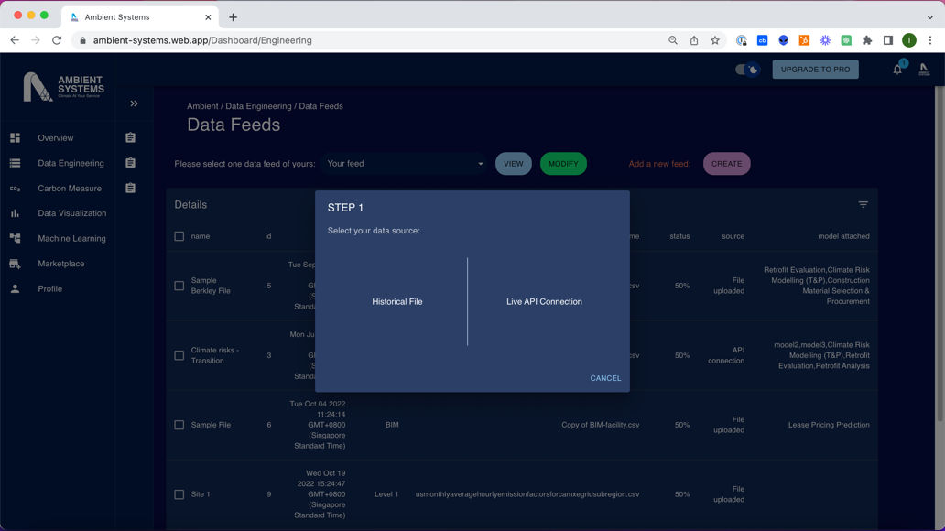

User Journey: Feature 1 – Combine Datasets
Connect existing platforms.
Connect traditional legacy databases without migration.

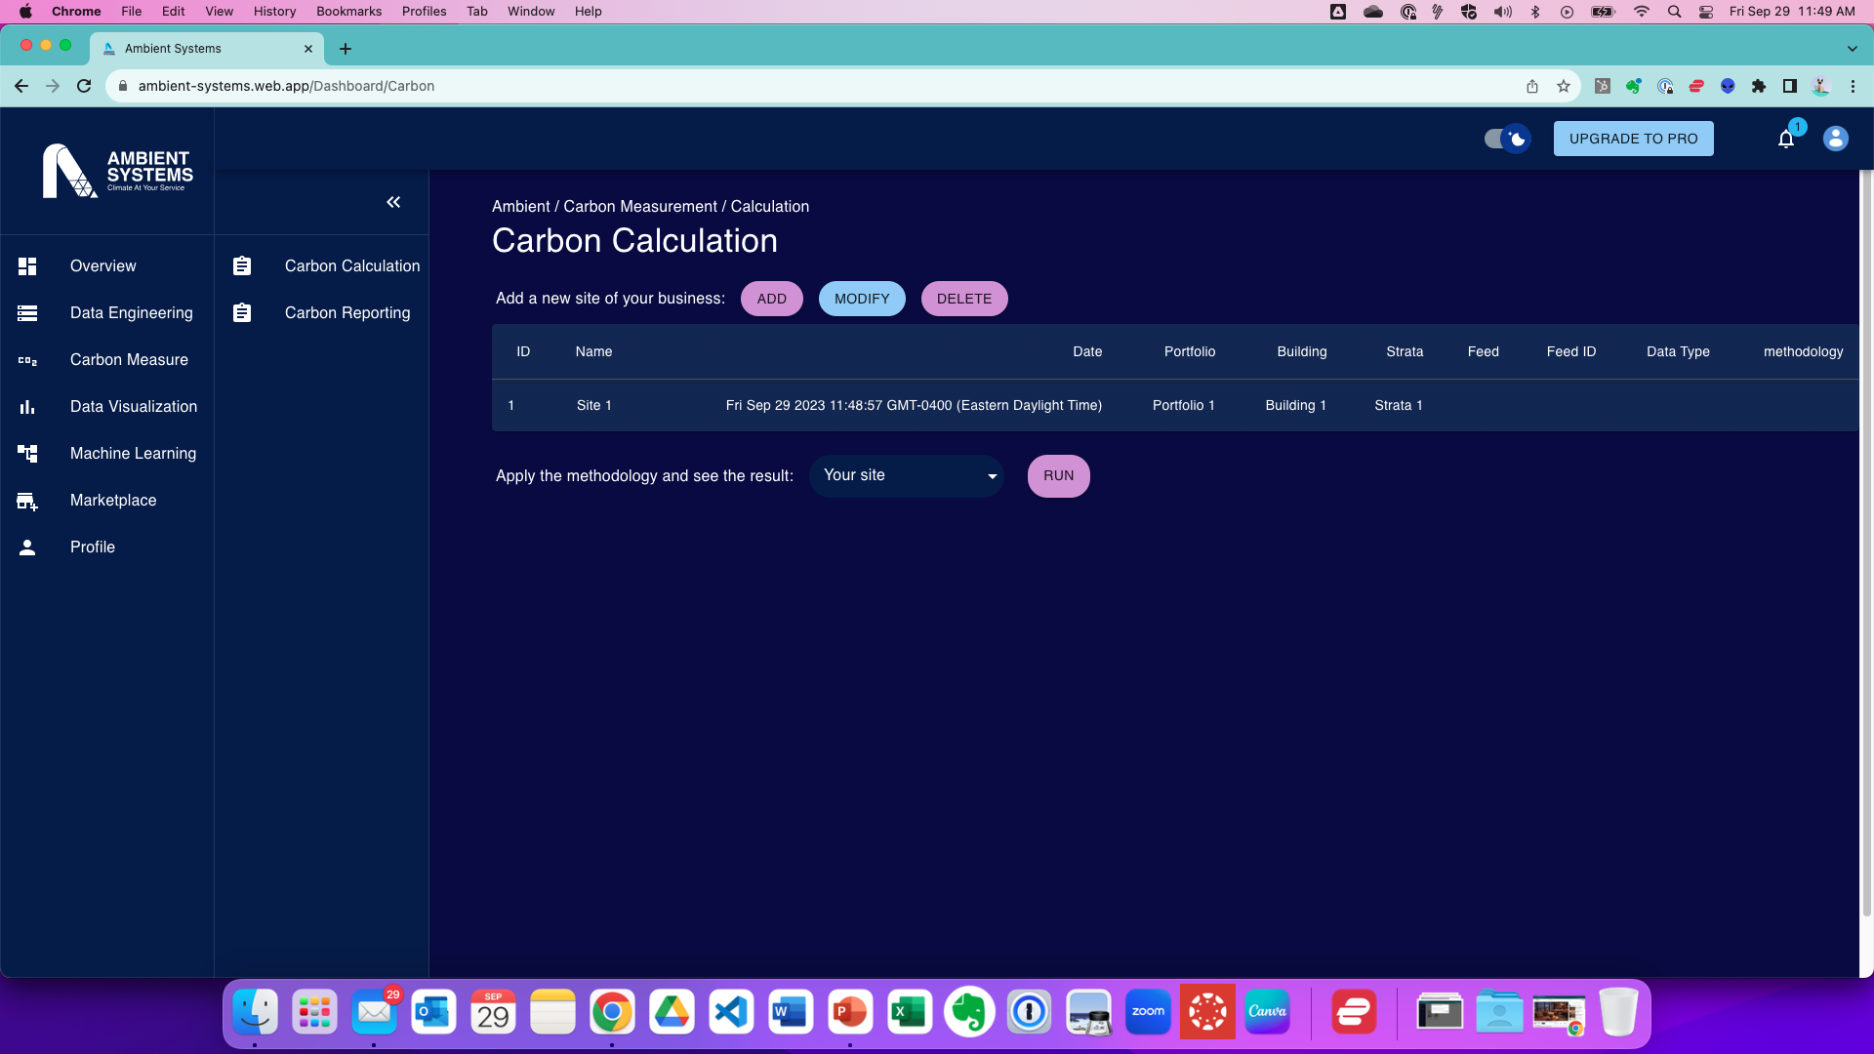

User Journey: Feature 2 – Automate Workflow
Key Features
Metric Library
Account Reconciliation
Auto-calculate Financial Performance Metrics
Compliance and Audit Reports

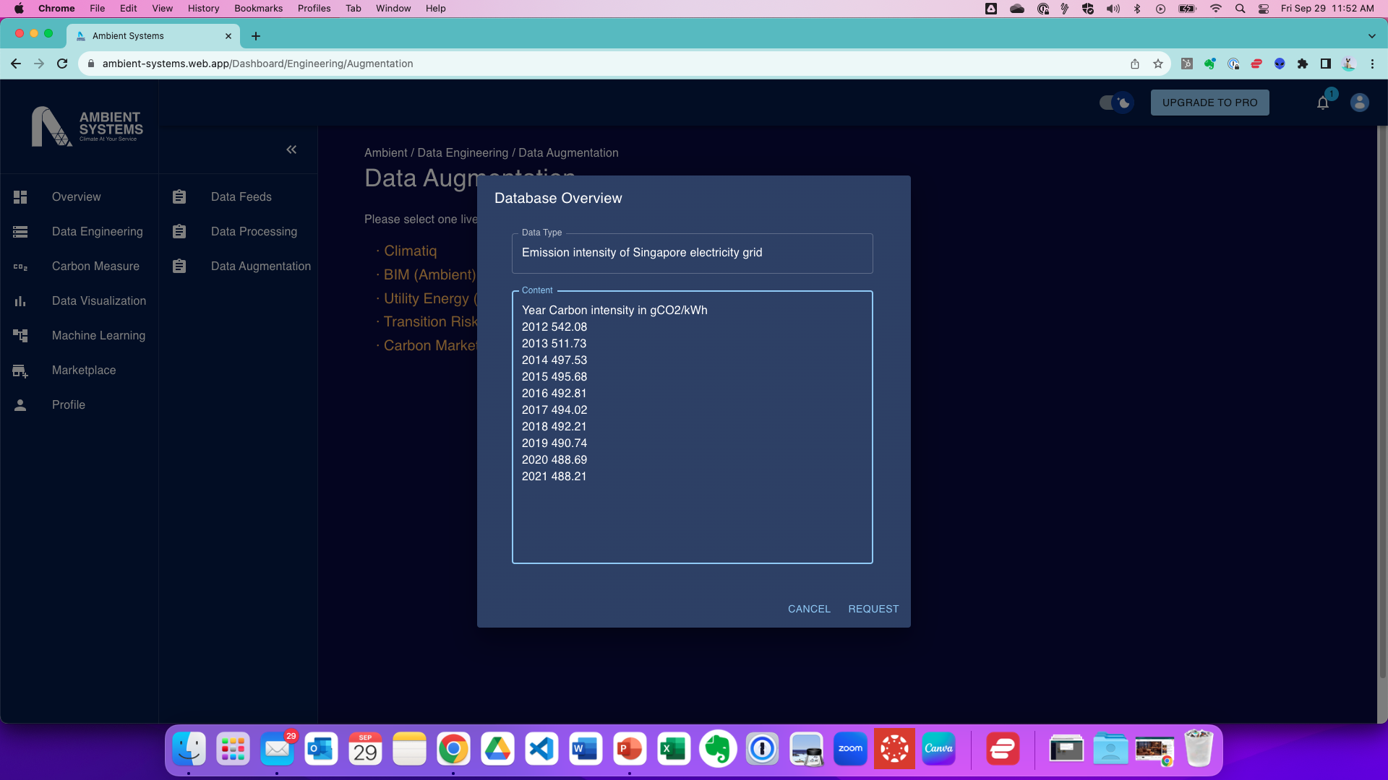
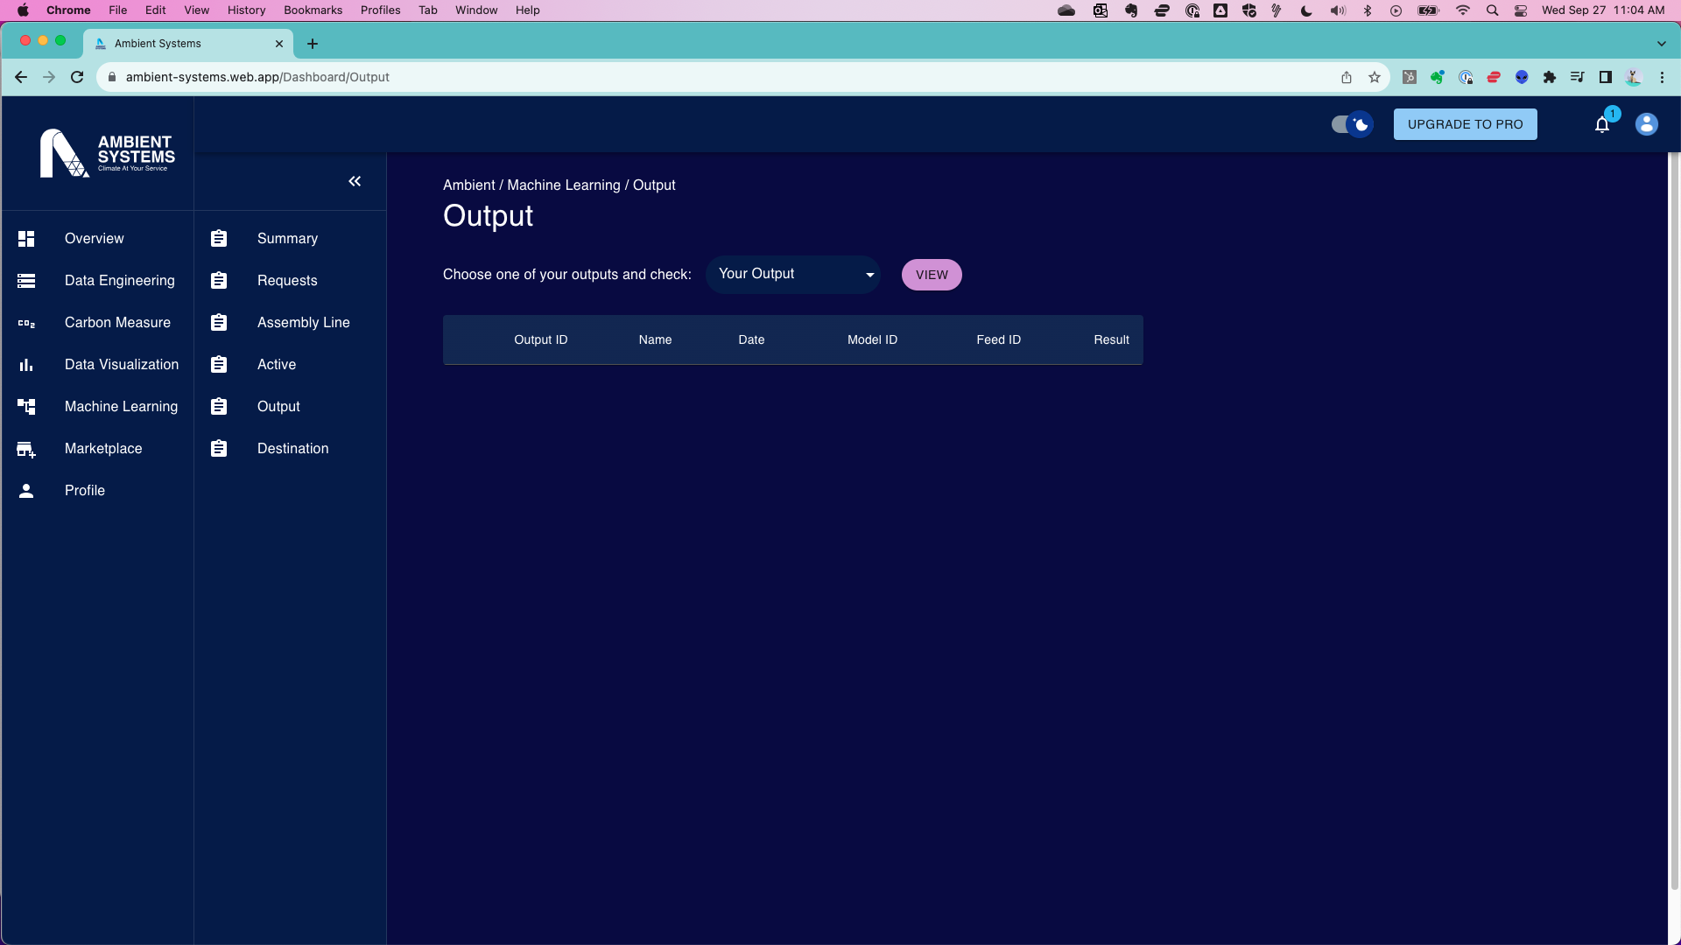
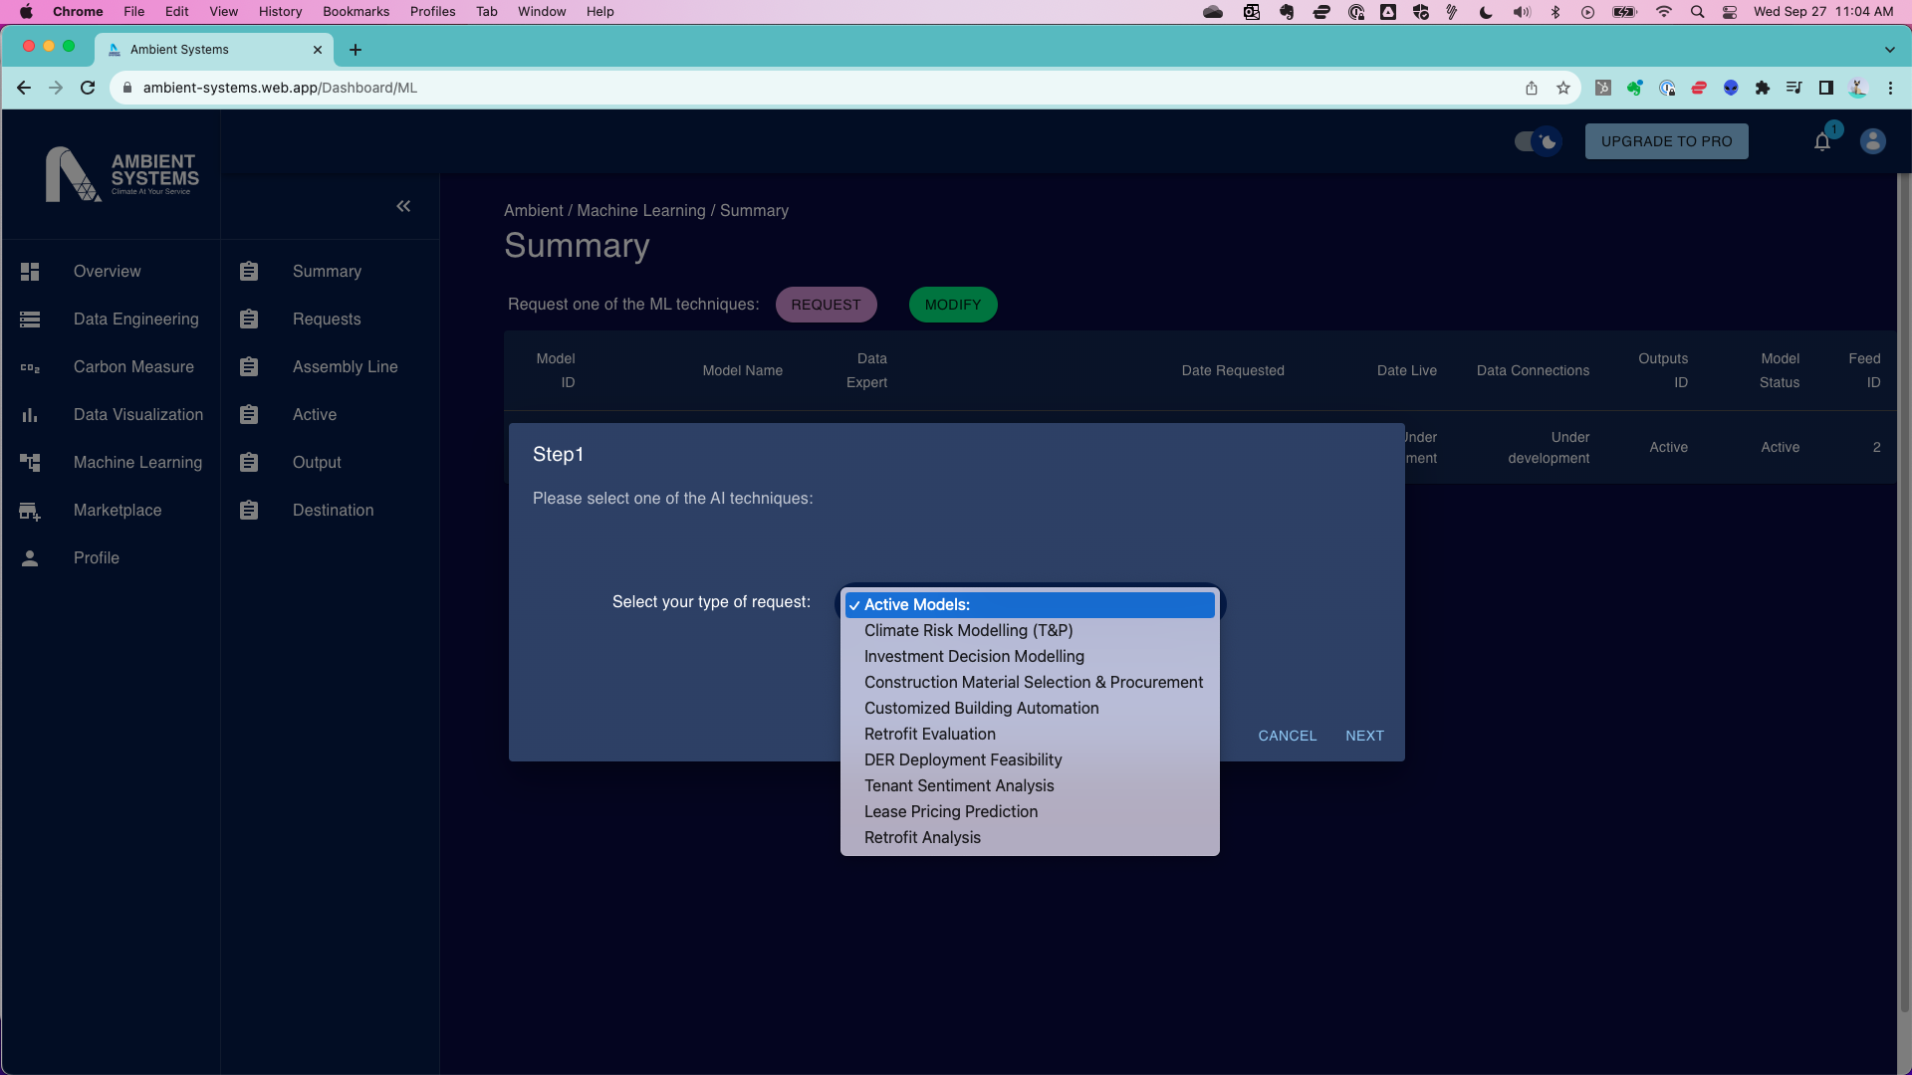

User Journey: Feature 3 – Add New Data
Key Features
New/Niche/Proprietary Datasets
Insightful Reports and Dashboards
Data Visualizations
Alerts and Notifications

User Journey: Step 5 – Output
Key ML Reports:
Predictions/Forecasts
Classification
Recommendations
NLP Outputs
Image/Video Output: Object detection, facial recognition, image captioning
Explanations/Interpretations

User Journey: Feature 4 – Leverage ML and AI
Key Features
Request model
Select datasets.
Assign data science expert
Future Functionalities

Feature | Description
Financial Analysis Module | Advanced financial modeling tools for projecting cash flow revenues and expenses across department units, assessing capital needs and ROI for new investments, and conducting scenario analyses specific to sustainability projects.
Resource Allocation and Budgeting Module | Tools for optimizing resource allocation, budgeting, and real-time tracking of expenditures for sustainability initiatives.
Reporting and Analytics Dashboard | Customizable dashboards for real-time visibility into financial performance metrics, KPIs, and progress toward sustainability goals.
Sustainability Metrics Integration | Tools to seamlessly integrate sustainability metrics, including ESG criteria, into the financial reporting framework. Ensure compatibility with industry standards and reporting frameworks.
Advanced Technology Integration | Leverage advanced technologies, such as artificial intelligence (AI) and Internet of Things (IoT) for predictive analytics and pattern recognition. Explore blockchain for transparent and secure tracking of sustainability data.
User-Friendly Interface | An intuitive and user-friendly interface to facilitate ease of use and adoption. Consider customization options to align with the workflows of finance professionals.
Scalability and Flexibility | Design the platform to be scalable to accommodate the evolving needs of growing organizations. Ensure flexibility to adapt to changes in sustainability regulations and reporting requirements.
Data Security and Compliance Features | Robust data security measures to protect sensitive financial and sustainability data. Ensure compliance with relevant regulations and standards governing financial reporting and sustainability practices.

Target Use Case Benefits
Ambient Systems is designed to help finance teams in smart infrastructure industries quantify their financial performance targets and improve them while maintaining sustainability. We focus on industries that have the greatest potential to contribute to economic growth and low carbon ‘net zero’ future:
- Transportation: empower transportation managers to streamline financial costs, optimize pricing models, and manage risk effectively in the dynamic transportation industry.
- Commercial Real Estate: empower real estate developers and owners to manage complex multi-location facility management operations, optimize revenue generation strategies, and achieve decarbonization and net zero targets by planning new investments through comprehensive real estate financial management tools.
- Construction: empower construction firms to gain real-time insights into project costs, manage cash flows effectively, and mitigate risks throughout the construction lifecycle with AI-enabled video and document analysis.

Overcoming Current Limitations
Ambient Systems addresses the following pain points that finance teams in the transportation industry face while using current ERP and Financial Planning & Analyses (FP&A) software for financial management.

- Forecast revenues and expenses.
- Long-term funding and investments
- Paying and managing taxes
- Cost control
- Managing cash flow and revenues
- Managing risks
- Ensuring compliance

Unique Value Proposition

- Comprehensive Financial Planning and Management Software (FP&M SW):
  - Today's Solution: Manual processes and complex data analysis.
  - Ambient Systems: Cloud-based FP&M SW with AI for streamlined automation, accurate forecasts, and data-driven decision-making.
- Enhanced Data Accuracy and Compliance:
  - Today's Solution: Traditional methods that result in data inaccuracies and compliance issues.
  - Ambient Systems: Advance data accuracy and compliance through AI and IoT integration.
- AI-Driven Recommendations:
  - Today's Solution: Lack of AI capabilities for actionable recommendations.
  - Ambient Systems' Solution: AI-driven insights for better decision-making in various financial domains.
- Addressing Multiple Financial Challenges:
  - Today's Solution: Disjointed processes for different financial challenges.
  - Ambient Systems: Unified platform addressing various financial aspects, streamlining operations.
- Integration of IoT and Data Collection:
  - Today's Solution: Limited integration with IoT and data collection.
  - Ambient Systems: Integration of IoT for real-time operational data, enhancing the accuracy of financial forecasts and continuous financial plan calibration.
- Improved Decision-Making and Profitability:
  - Today's Solution: Lack of clear financial goals and communication channels with data scatter across departments and users.
  - Ambient Systems: Comprehensive financial tools, AI-driven insights, and data integration lead to better decision-making, cost reduction, and improved profitability.

Key Benefits
By addressing the pain points mentioned and delivering the unique value proposition points, Ambient Systems offers businesses several key benefits that are likely to drive various benefits for the business.
- Improved financial visibility: Businesses can gain a holistic view of their financial performance across all departments and data sources, enabling better decision-making.
- Enhanced agility and responsiveness: Real-time insights and forecasting empower businesses to make informed decisions quickly and proactively adapt to market changes.
- Increased productivity and efficiency: Intuitive user interfaces make it easier for non-financial professionals to access and understand critical financial information, freeing up time for more strategic tasks.
- Reduced risk and improved financial outcomes: AI-powered risk assessment and predictive analytics help businesses identify potential risks and opportunities, leading to better financial returns.

Technological Advantage
Ambient Systems outperforms traditional solutions with a powerful combination of cloud computing, AI, and IoT technologies in various ways.
- Overcome Limited Data Integration: Ambient Systems integrates with IoT and data collection systems to capture real-time operational data, providing a holistic view of business operations.
- Ensure Data Accuracy and Compliance: Ambient Systems utilizes AI verification and anomaly identification to ensure the accuracy and compliance of financial data, reducing the risk of errors and regulatory non-compliance.
- Fill the Gap in AI Capabilities: Ambient Systems leverages AI-driven recommendations to enhance decision-making in various financial aspects, from revenue forecasting to risk management.
- Integrate across Cloud Platforms: Ambient Systems provides high-performance computing available through a distributed network of systems with unparalleled performance advantages, enabling real-time data processing and analysis.

